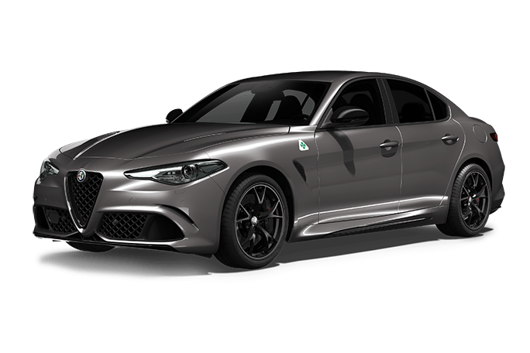

Alfa Romeo

Giulia Quadrifoglio

2021

90 000

Diesel

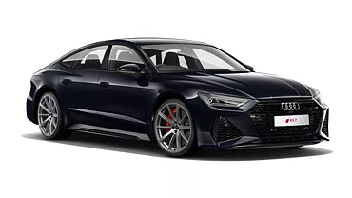

Audi

RS7

2020

150 000

Diesel

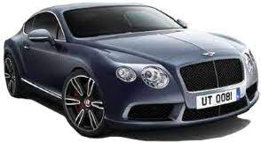

Bentley

Continental GT

2023

280 000

Essence

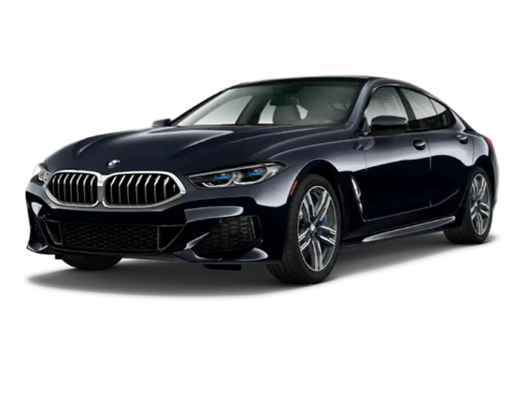

BMW

SERIE 8

2022

100 000

Essence

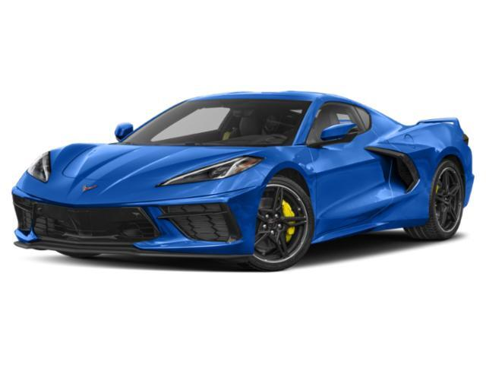

Chevrolet

Corvette

2021

90 000

Essence

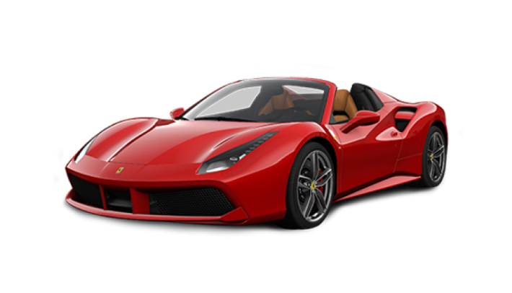

Ferrari

488 GTB

2019

260 000

Essence

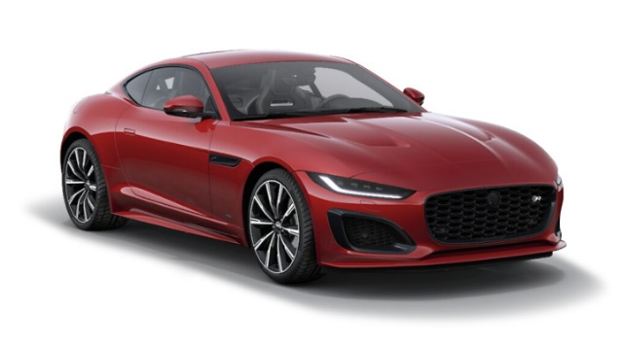

Jaguar

F-Type

2021

95 000

Essence

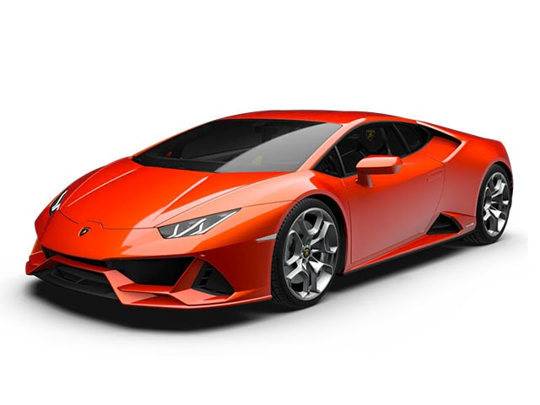

Lamborghini

Huracan EVO

2021

Essence

250 000

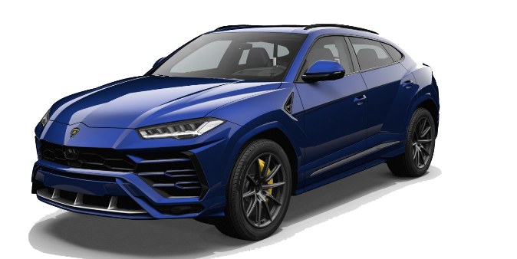

Lamborghini

Urus

2020

Essence

215 000

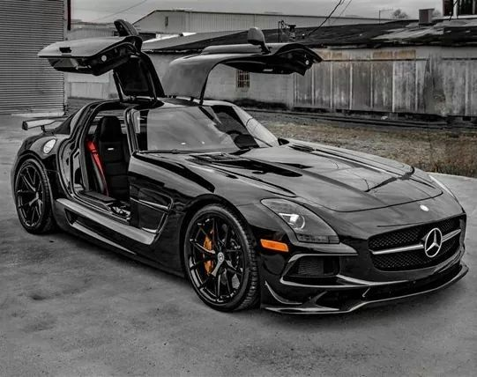

Mercedes

AMG SLS Black Series C197

2014

Essence

260 000

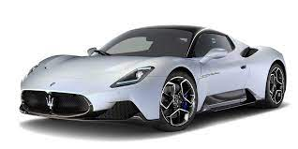

Maserati

MC20

2021

Essence

235 000